**ECHO README**

Thank you for downloading ECHO (Extended Circadian Harmonic Oscillations)! ECHO is an app designed to find and identify circadian rhythms from your data, then visualize the results. This guide will lead you in first time set-up and use. Pictures have been provided for ease of use, using Windows 7. An asterisk indicates the step has an explanation below, and a tilde indicates the step is first-time set up only.

Last updated: 11/17/17 (ECHO version 0.3)

Steps:

1. *~ Download Firefox (https://www.mozilla.org/en-US/firefox/new/) or Chrome (https://www.google.com/chrome/browser/desktop/index.html) and make it your default browser.
2. ~ Download R, if you do not already have it: https://www.r-project.org/
3. ~ Download RStudio, if you do not already have it (RStudio Desktop is sufficient): https://www.rstudio.com/products/rstudio/download/
4. Open RStudio. It should look something like this:

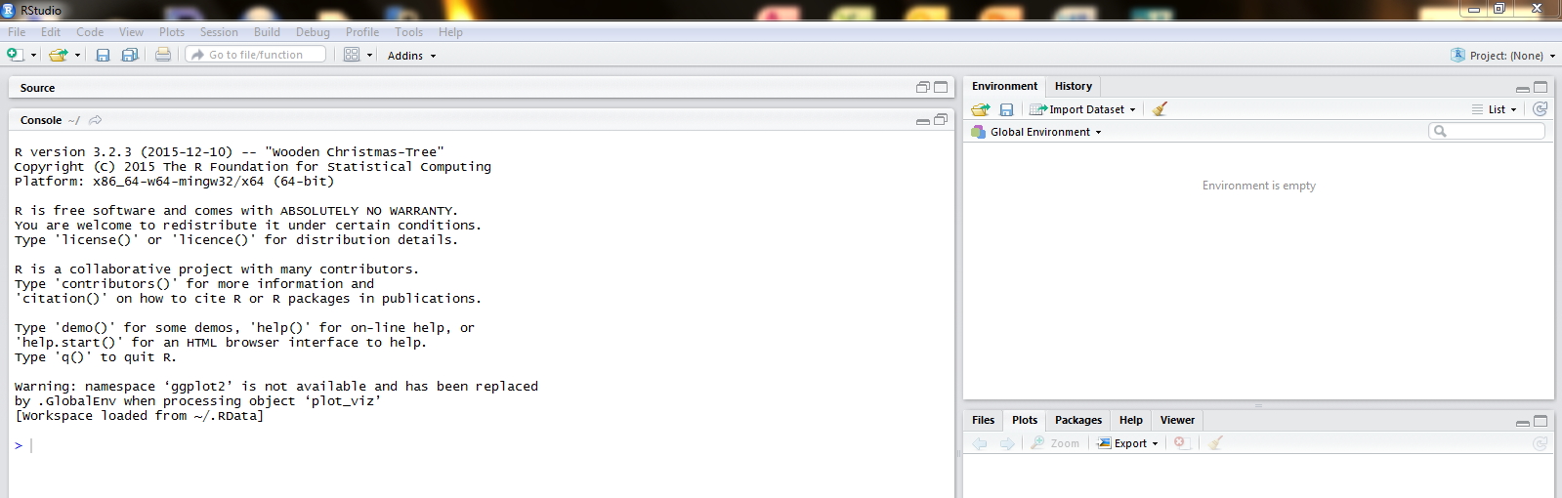

1. ~ Copy and paste the following text into the console window (bottom right window of the RStudio Session), then press enter:

install.packages("rstudioapi")

install.packages("shiny")

install.packages("ggplot2")

install.packages("VennDiagram")

install.packages("reshape2")

install.packages("minpack.lm")

install.packages("doParallel")

install.packages("foreach")

install.packages("iterators")

install.packages("doSNOW")

install.packages("colorRamps")

install.packages("fields")

This will install these packages (a set of functions that this application uses) onto your computer. This may ask for your input, so just say yes to the questions asked. If you run into errors saying “yes,” just say no instead. Note: this may take some time.

1. Open app.R, which should be included in the .zip file you downloaded and also contained this README. It should open in the top left window of your RStudio session.

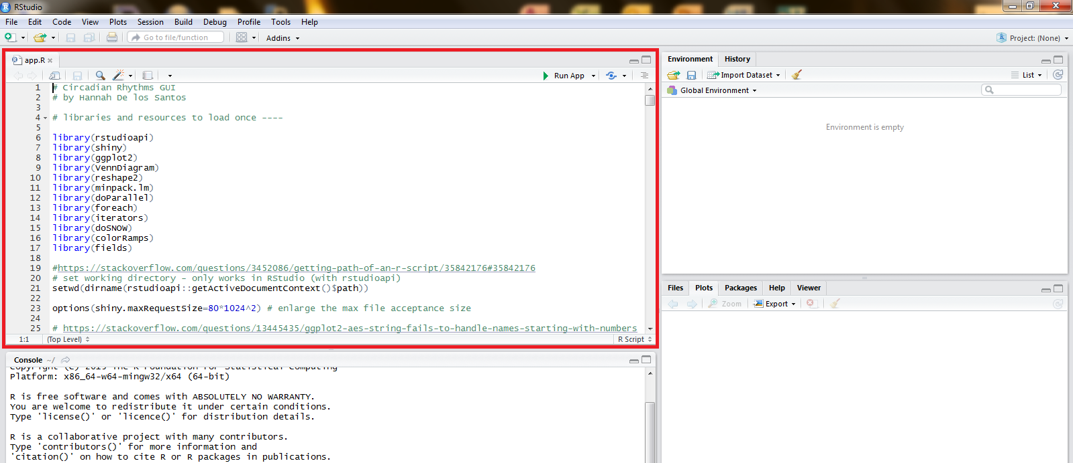

1. In the top right corner of the app.R window, you should see the button, “Run App”. Click on the small downwards arrow next to it and choose “Run External”.

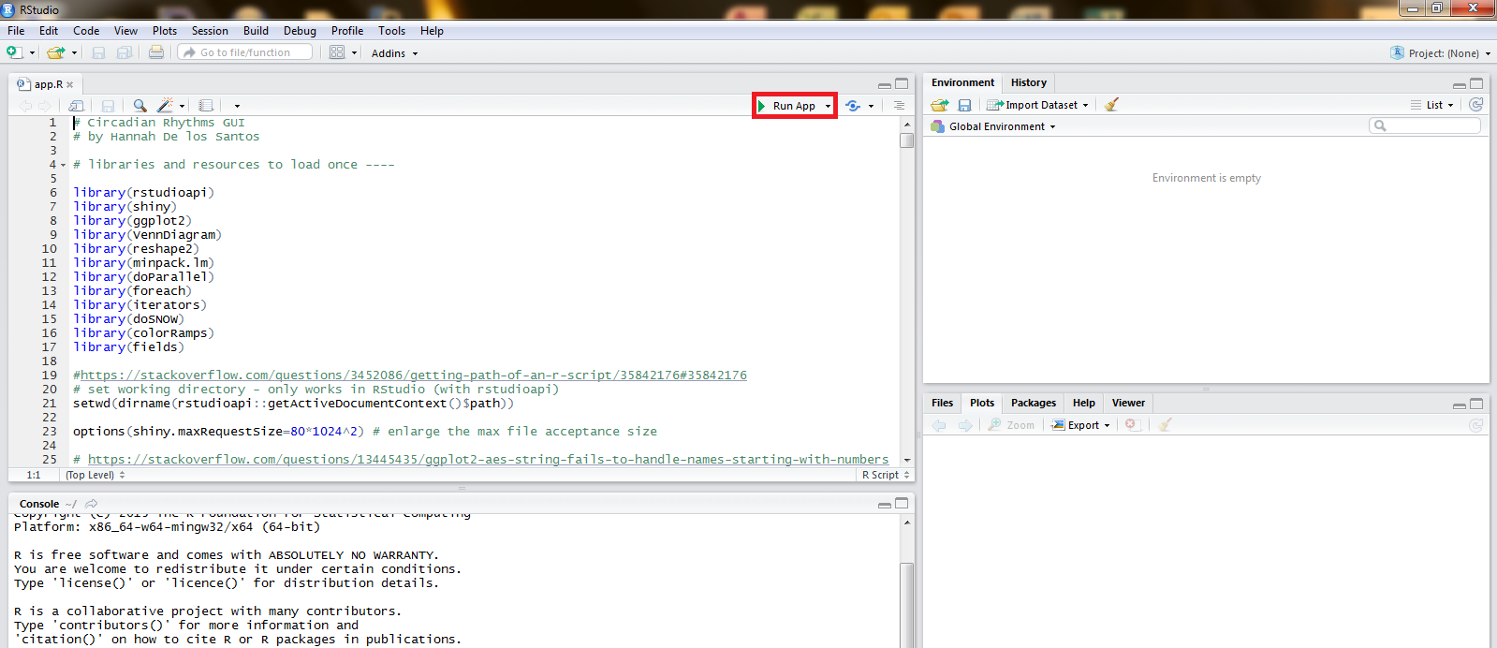

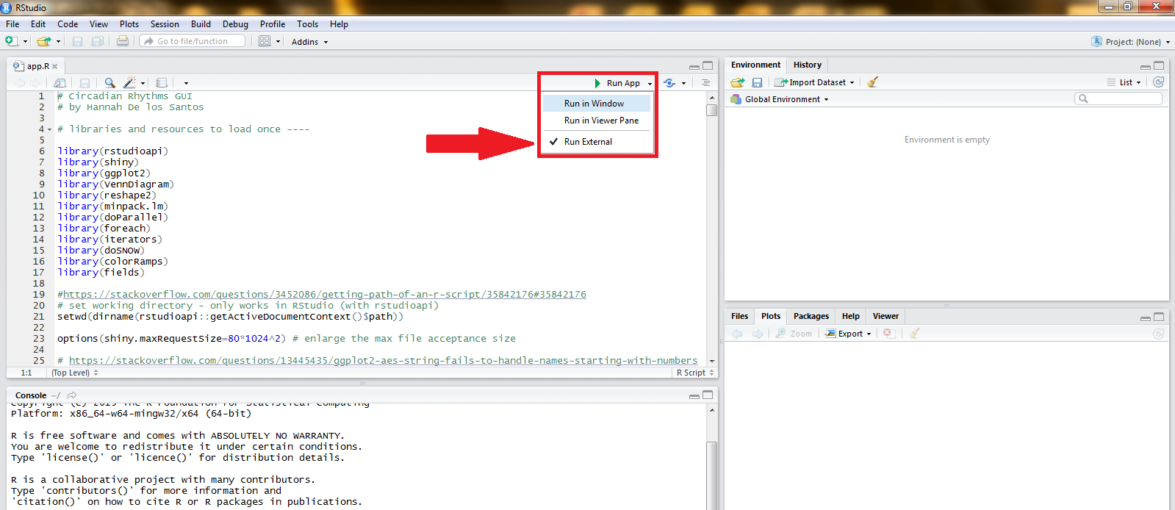

1. Now click “Run App”. This should open the ECHO application in your now default browser window (either Firefox or Chrome). The picture below is a representation in Firefox.

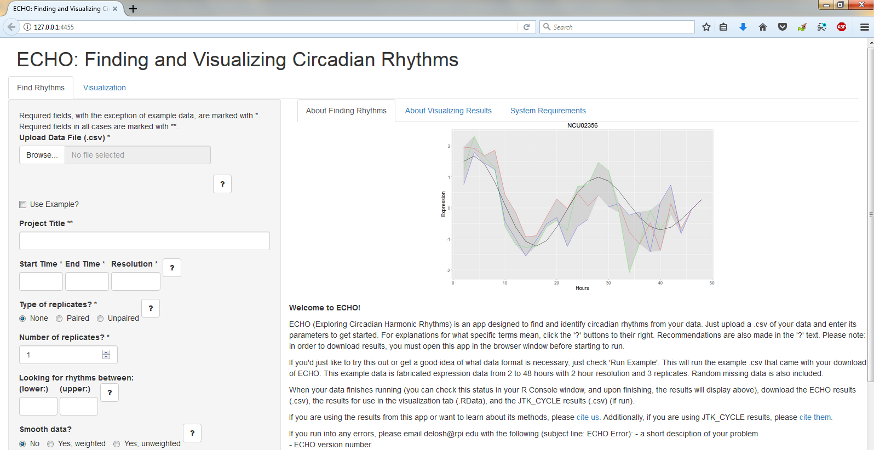

1. Have fun!

* Why do I have to install either Firefox or Chrome, you ask? Why not Internet Explorer, or some other browser? Well, it is known there are problems downloading files when viewing shiny apps in Internet Explorer, so we definitely want to avoid that. However, I have not tested this app in browsers like Microsoft Edge, Safari, etc. If you can verify that these work, please let me know at delosh@rpi.edu.